

P.E.S. COLLEGE OF ENGINEERING,
(An Autonomous Institute under Visvesvaraya Technological University, Belagavi)
MANDYA-571401

MINI PROJECT REPORT ON
“Analysis of Sentiment Detection Tool”
Submitted in partial fulfilment of the requirement For the award of the
BACHELOR OF ENGINEERING DEGREE

Submitted by

Thrishool M S 4PS23EC167
Nagapooja G S 4PS23EC081
Gagan N T 4PS23EC033
Thanushree M S 4PS23EC186

Under the guidance of
Dr. M J Anand


Associate Professor

Department of Electronics and Communication Engineering
P.E.S. College of Engineering
Mandya 2025-2026

Abstract

This project presents a machine-learning-based Sentiment Analysis Tool designed to classify user-generated text as positive, negative, or neutral. With the rapid growth of social media, customer reviews and online feedback systems, understanding public opinion automatically has become essential for businesses, organizations and research communities. Manual analysis of large-scale text data is time-consuming, inaccurate and highly subjective.
The proposed system uses pre-trained transformer models such as BERT and RoBERTa to analyse sentence-level sentiments with high accuracy. A lightweight web interface is implemented, allowing users to enter text, submit it for analysis and instantly view the sentiment classification. Additionally, the tool supports visual sentiment analytics, where trends are plotted in the form of charts or graphs. This system provides efficient, real-time sentiment insights and can be adapted for tweets, reviews or custom datasets.

 | INDEX
INDEX NO | DESCRIPTION | PAGE NO
1 | Introduction | 1
2 | Literature Survey | 2
3 | Problem Statement | 3
4 | Objectives | 4
5 | System Block Diagram / Methodology | 5
6 | Flow Chart with Working Mechanism | 6
7 | Expected Outcome | 7
8 | References | 7
9 | Feedback Form | 8

Introduction

Sentiment analysis, often called opinion mining, is a widely used AI technique for determining the emotional tone behind textual data. With the explosion of social media platforms, people openly express their opinions about products, movies, services and public events. Analysing this data manually becomes unrealistic when millions of posts are generated every minute.
Traditional machine learning techniques like Naive Bayes and SVM have shown moderate performance but fail to capture contextual meaning, sarcasm and linguistic variations. Modern transformer-based models such as BERT, RoBERTa and DistilBERT provide state-of-the-art text understanding, enabling more accurate sentiment classification.
The goal of this project is to design a simple, scalable and user-friendly web-based sentiment analysis tool that processes user input, classifies the sentiment and displays outputs along with visual graphs. The tool can be used for social media monitoring, customer feedback evaluation, product review analysis and academic research involving opinion studies

Literature Survey
According to B. Pang and L. Lee in their paper "Opinion Mining and Sentiment Analysis" (2008),
Early automated sentiment discovery relied primarily on statistical machine learning algorithms like Naive Bayes (NB) and Support Vector Machines (SVM).
These foundational models used a simple "Bag-of-Words" approach that counted standalone word frequencies to classify texts. Because they lacked true context awareness, rendering them entirely unable to resolve sarcasm.
To improve upon these baseline limitations, A. L. Maas et al. introduced a new methodology in "Learning Word Vectors for Sentiment Analysis" (2011) using continuous, low-dimensional word vector embeddings.
This development allowed systems to map latent semantic relationships, resulting in much higher classification accuracy on benchmark datasets like IMDb movie reviews.
However, these word representations remained static, meaning a word with multiple meanings received the exact same vector score regardless of how its context shifted within a sentence.
Our current architecture overcomes these bottlenecks by utilizing the deep bidirectional transformer models introduced by J. Devlin et al. in "BERT: Pre-training of Deep Bidirectional Transformers for Language Understanding" (2019) and optimized by Y. Liu et al. in "RoBERTa: A Robustly Optimized BERT Pretraining Approach" (2019).
Powered by a multi-head self-attention mechanism, these modern models read entire text strings simultaneously to process context bi-directionally.
By integrating these pre-trained transformer cores, our system successfully handles complex slang and contextual negations, passing model outputs into a Softmax layer to generate highly precise confidence percentages within milliseconds to dynamically update the frontend analytics charts.

Problem Statement

With the rapid growth of digital communication, users frequently post opinions, reviews and feedback online. However, organizations and researchers struggle to manually process large volumes of text data to understand public sentiment. Traditional sentiment analysis models lack contextual understanding and often produce inaccurate results when exposed to slang, sarcasm or complex sentence structures.
There is a need for a modern, AI-powered sentiment analysis tool capable of understanding context, providing accurate sentiment classification and visualizing trends over time. Existing tools are either domain-specific, require technical expertise, or charge subscription fees. Therefore, a customizable, user-friendly sentiment analysis system is required to analyze text from tweets, reviews and general user input in real-time.

Objectives

- To develop a sentiment analysis system using transformer-based NLP models such as BERT and RoBERTa trained on the IMDb movie review dataset for accurate classification of reviews as positive or negative.
- To design and implement a user-friendly web interface that enables users to input movie reviews or custom text and receive instant sentiment predictions along with confidence scores.
- To evaluate the performance of the sentiment analysis model using metrics such as accuracy, precision and recall, along with graphical representations like bar charts and pie charts for better interpretation of sentiment results.
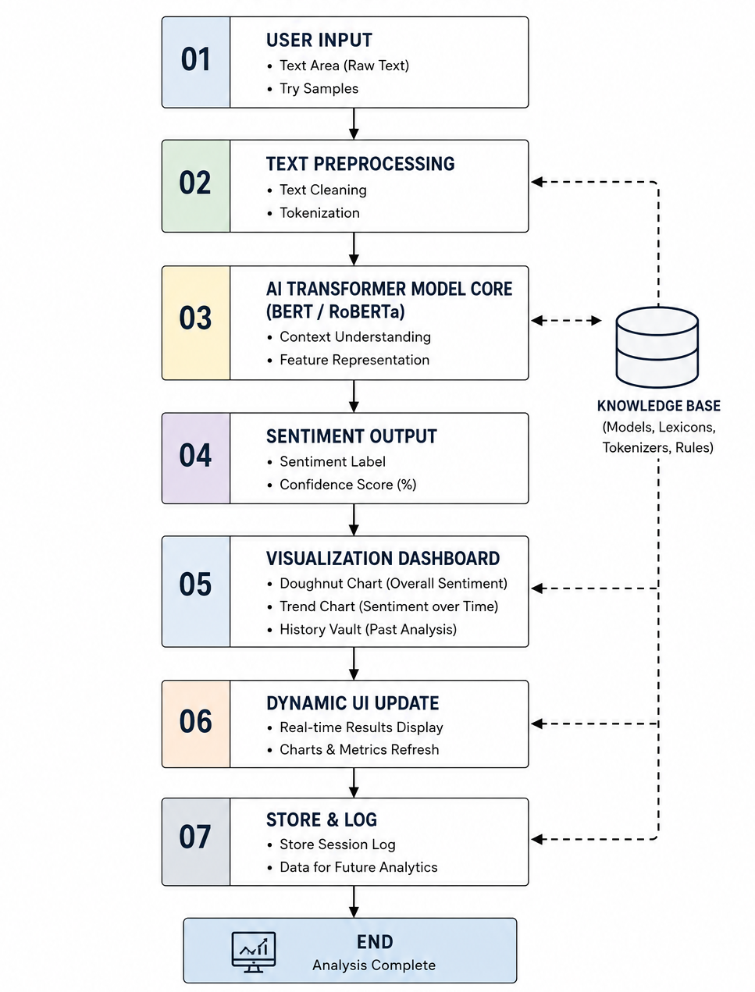
System Block Diagram / Methodology
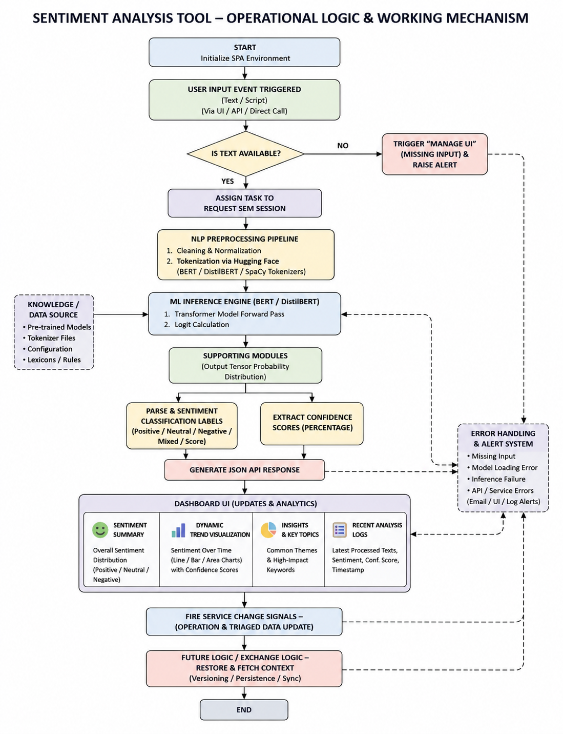

Expected Outcome
- A fully functional real-time sentiment analysis tool.
- Accurate sentiment predictions powered by transformer-based AI models.
- A simple and responsive web interface for sentiment input.
- Visualization of sentiment insights using line charts, pie charts or bar graphs.
- Ability to analyse tweets, reviews or custom user inputs.
- Extendable framework for future domain-specific sentiment analysis applications.

References
- B. Pang, L. Lee, “Opinion Mining and Sentiment Analysis,” Foundations and Trends in Information Retrieval, Vol. 2, No. 1–2, pp. 1–135, 2008.
- Maas, A. L. et al., “Learning Word Vectors for Sentiment Analysis,” Proceedings of the 49th Annual Meeting of the Association for Computational Linguistics (ACL), 2011.
- J. Devlin, M. Chang, K. Lee, K. Toutanova, “BERT: Pre-training of Deep Bidirectional Transformers for Language Understanding,” NAACL-HLT, 2019.
- Y. Liu et al., “RoBERTa: A Robustly Optimized BERT Pretraining Approach,” arXiv preprint arXiv:1907.11692, 2019.

Feedback Form

  - The synopsis is formatted as per the template. Yes/No.
  - Objectives and problem statement are properly formulated. Yes/No.
  - Picture-diagrams-tables are numbered properly. Yes/No.
  - Syntax and Grammar usage is standard. Yes/No.
  - References are cited properly and listed in order. Yes/No.
  - Remarks and comments.

Signature of the Guide Signature of the Mini-Project Coordinator

